# ANNEX 1 – Software Architecture Template

The Software Architecture document should **briefly describe how the technical solution** to the given requirements will look like.

In the following lines we will describe what sections should be present in this document, and what kind of information we expect in each section.

## High Level Architecture Diagram

In this section you should provide a UML diagram which describes the main components from each layer (Front-End/Back-End), of the system that you will build.

Here is an example diagram:

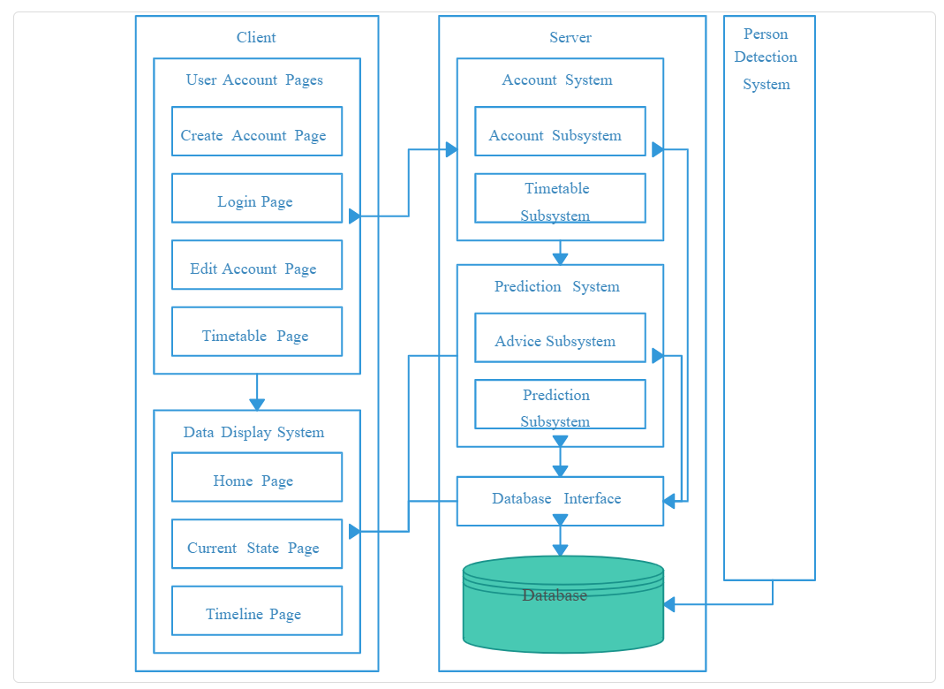

In this example diagram we can observe the following:

* The system has three components: **Client**, **Server,** and **Person Detection System**
* Client and Server contain various modules which interact with each other (cross layer or within the same layer)

You should create a similar diagram for your system, where you describe what modules will be present in every layer and what relations exist between them.

**Note:**

* The above diagram is only for inspiration, you don’t need to organize the modules exactly like here. Please adapt the drawing to the needs of the system you’re building and make sure that the diagram has a logical explanation.

For diagraming, you could use one of the following tools (or anything else you like):

* [Lucidchart](https://www.lucidchart.com/)
* [Visual Paradigm Community Edition](https://www.visual-paradigm.com/download/community.jsp)
* [Cacoo (free version)](https://cacoo.com/)
* https://app.diagrams.net/

## 

## Data Model Diagram

Because for the current project we recommend using a NoSQL database (Cosmos DB), we require a **data model diagram** instead of an ERD (Entity Relationship Diagram), as we would do for a relational database.

You can learn how to draw such a diagram by reading the following article: <https://www.techighness.com/post/how-to-draw-no-sql-data-model-diagram/>

For diagraming, as the above article suggests, you could use the following tool:

* https://app.diagrams.net/

You are free to use other tools as well, as long as the result resembles a data model diagram as shown in the above article.

**Tips:**

* In order to create the data model diagram, you should start by carefully reading the requirements and thinking about what data entities should exist in the system. For each data entity you should then think what actual properties need to be stored and you’re almost done. It remains only to define the relations between entities and your there. This is explained in better words and examples in the above article.

## List of Technologies

In this section you should write a list with all applications/frameworks/libraries which you will use to develop your product, together with the purpose of that technology.

**Example:**

|  |  |  |
| --- | --- | --- |
| **Technology Name** | **Type** | **Purpose** |
| Cosmos DB Service | Application | Hosting the database |
| Azure App Service | Application | Hosting the website |
| Bootstrap | Javascript Library | Develop some UI controls (Form, Input Group, etc.) |
| React | Javascript Framework | Develop UI |
| TinyXml | C++ library | Parse XML data |
| … | … | … |